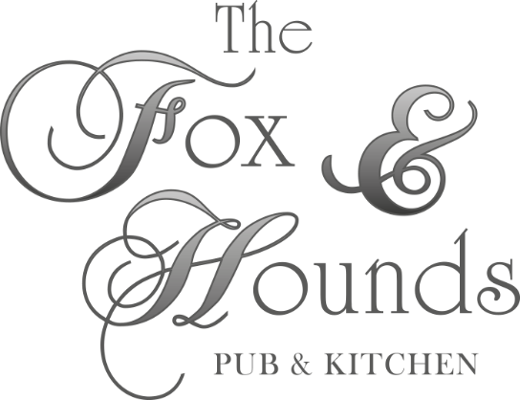
Christmas Party menu £25.95 per head
(min 4 persons)
Pre order

To start
Seasonal vegetable soup (v)
Served with fresh baguette & butter
Potato skins
Loaded with cheese & bacon or cheese & onion (v) served with sour cream
Prawn cocktail
Served with fresh bread & butter
Brushetta (v)
Tomato & basil

Main course
Roast Turkey
Served with stuffing & pigs in blankets
Oven baked fillet of Seabass
Served with a dill & prawn sauce
Sirloin of Beef
Served with red wine gravy & a yorkshire pudding
Butternut Squash Risotto (v)
Served with parmesan shavings & rocket leaves
*All dishes served with roast potatoes & market fresh vegetables

Dessert
Passion fruit cheesecake
Served with fresh cream
Christmas pudding
Served with brandy sauce
Chocolate brownie
Served with ice cream
Cheese Board & biscuits

*Any food allergies or special requests please make us aware at the time of ordering
The Fox & Hounds Pub & Restaurant
Walton Street, Walton on the hill. Surrey KT20 7RU
www.foxandhounds.net
01737 817744
fox@aurabars.co.uk
*Function room also available for hire (please ask for further details)

